ENG 220 Form Lesson

Before Class
Read Rebecca Hazelton “Why write in form?” From Poetry.Com

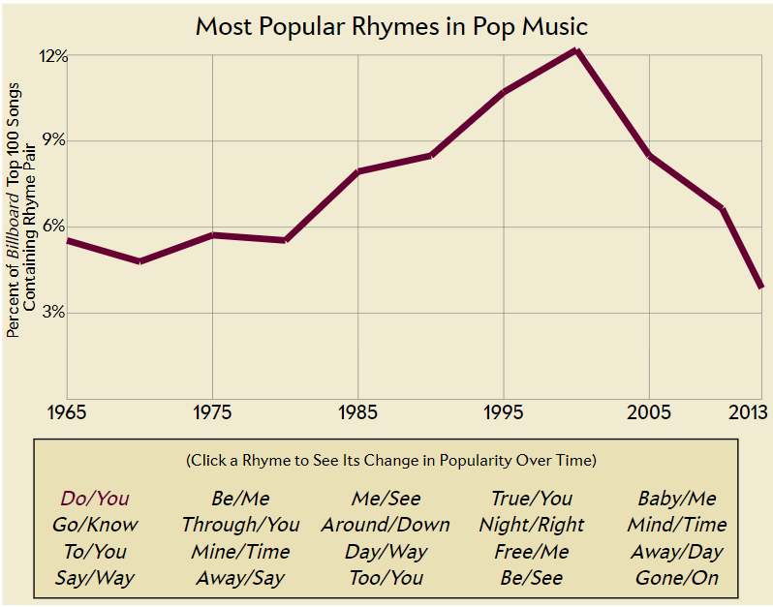
Opening Activity: Cliché Rhymes (15m)
[I found this list of most popular rhymes in pop music, so I thought I would use it for a warm up activity.]
1. Choose one of the duos on this list. Write 2 lines that end in these rhymes. Try not to use any cliches.
2. When you are finished pair&Share

Instruction: Poetic Form (15-20m depending on if adding discussion)
[We talk about the reading a little. If they agree, if they disagree. Why the writer says we should write in form. If they like writing in form. Etc.]
Then I explain some elements of form
- Poetic Form is the structure of a poem or the pattern it follows, including line length, rhyme, repetition, rhythm, and subject.
- Prosody is the patterns do rhythm and sound used in poetry
- Stanza is a grouping of lines in a poem, usually separated by space
- Meter – pattern of beats and stresses in poetry
- Rhythm is a strong, regular, repeated pattern of movement or sound. the pattern of stresses within a line of verse. The rhythm can be consistent or varied depending on the feeling you want to express
- Rhyme Scheme – the rhyming pattern of the poem, how each line ends
  - True rhyme – the words fully rhyme
  - Slant rhyme – the words almost rhyme

Example: My boi Willy (10m)
[We then read this sonnet out loud. I don’t tell them anything about the form yet, we just talk about the techniques we notice. I like this one because it seems like he is insulting her and then the students have to think about his actual meaning.]
William Shakespeare, Sonnet 130
My mistress' eyes are nothing like the sun;
Coral is far more red than her lips' red;
If snow be white, why then her breasts are dun;
If hairs be wires, black wires grow on her head.
I have seen roses damasked, red and white,
But no such roses see I in her cheeks;
And in some perfumes is there more delight
Than in the breath that from my mistress reeks.
I love to hear her speak, yet well I know
That music hath a far more pleasing sound;
I grant I never saw a goddess go;
My mistress when she walks treads on the ground.
And yet, by heaven, I think my love as rare
As any she belied with false compare.

[Then, I show them this beautiful scantron I did on the poem and we discuss the characteristics of a Shakespearean sonnet.]
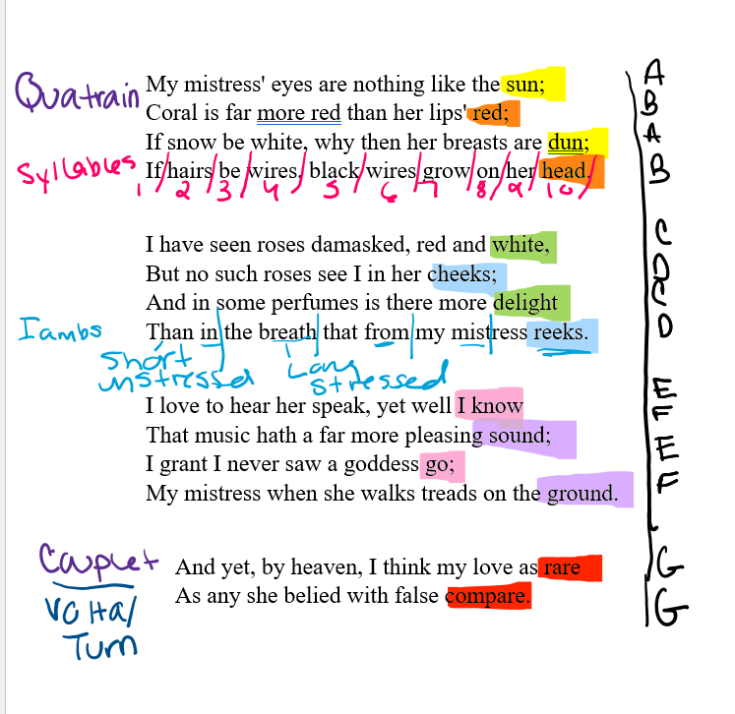

Characteristics:
14 lines
ABAB rhyme scheme
3 quatrains and a couplet
Couplet is called the volta because it turns the poem/shows the meaning.
Iambic Pentameter

Exercise: Writing Sonnets

Part 1: Analyzing (10m)
PREP: I printed out pairs of modern and classical sonnets that are generally on the same theme. I found them all on the sonnet page on Academy of American Poets Website, but I will include the pairs below. There are some one that are nice on the list that I left out because we were already reading that author on another day. (In one pair, the modern author is actually copying the name&form of the classical one.)
IN CLASS: I put the pairs face down on my desk and wrote the theme on the back, so the students could see the theme but not the poems.
I tell the students that the goal is to see how different authors use the same form in various ways.
I had the student group up, in groups of 4, and send one person to pick out one pair of poems. [very helpful for ankle sprain but also fun to say 3 2 1 go and watch them panic&grab]
In their groups, they read the poems and discussed the techniques and choices each writer made. They could focus on imagery, line, adherence to form, etc. Anything that is a choice. (We are working on reading like writers.)
When they were done, we went around the room and talked about some of these techniques.
I also had each group read their favorite of the two. This is optional.

Part 2: Writing (15m)
Now, for the juice. I asked the students to write one stanza -- one quatrain -- of a traditional Shakespearean sonnet on the same theme as their two example sonnets.
I did them not to worry so much about the stressed and unstressed syllables because that also confuses me, but I did them to try and only use 10 syllables per line.
So, they write. I always write with them. And then when they are finished I tell them to pair and share.
When they are done with that, I ask if anyone wants to share outloud. Usually, this is poppin, but not a lot of them were confident in their forms. This is okay.

Closing the Day: Reflect and Connect (10m)
Aside from telling them their homework, I try to end the day by reflecting on the writing activity and connecting it to their growing knowledge of poetry/writing. You know, how did it feel to write in a strict form? If you didn’t like this form do you think you would like others (we had read a pantoum earlier in the week)? Are any of you considering expanding on this activity for your peer reviewed poem? (One was!) How does this writing compare to your feeling on past writing activities? Etc. etc.

Then class is over.

Sonnet Examples

Theme: Religion

Batter my heart, three person'd God (Holy Sonnet 14)
John Donne - 1571-1631
Batter my heart, three-personed God, for you
As yet but knock, breathe, shine, and seek to mend;
That I may rise, and stand, o'erthrow me, and bend
Your force to break, blow, burn, and make me new.
I, like an usurped town, to another due,
Labour to admit you, but Oh, to no end.
Reason, your viceroy in me, me should defend,
But is captived, and proves weak or untrue.
Yet dearly I love you, and would be loved fain,
But am betrothed unto your enemy:
Divorce me, untie or break that knot again,
Take me to you, imprison me, for I,
Except you enthrall me, never shall be free,
Nor ever chaste, except you ravish me.

Batter My Heart, Transgender’d God

Meg Day
Batter my heart, transgender’d god, for yours
is the only ear that hears: place fear in my heart
where faith has grown my senses dull & reassures
my blood that it will never spill. Show every part
to every stranger’s anger, surprise them with my drawers
full up of maps that lead to vacancies & chart
the distance from my pride, my core. Terror, do not depart
but nest in the hollows of my loins & keep me on all fours.
My knees, bring me to them; force my head to bow again.
Replay the murders of my kin until my mind’s made new;
let Adam’s bite obstruct my breath ’til I respire men
& press his rib against my throat until my lips turn blue.
You, O duo, O twin, whose likeness is kind: unwind my confidence
& noose it round your fist so I might know you in vivid impermanence.

Theme: History/Myth

Ozymandias
Percy Bysshe Shelley

I met a traveller from an antique land
Who said: "Two vast and trunkless legs of stone
Stand in the desert . . . Near them, on the sand,
Half sunk, a shattered visage lies, whose frown,
And wrinkled lip, and sneer of cold command,
Tell that its sculptor well those passions read
Which yet survive, stamped on these lifeless things,
The hand that mocked them, and the heart that fed:
And on the pedestal these words appear:
'My name is Ozymandias, king of kings:
Look on my works, ye Mighty, and despair!'
Nothing beside remains. Round the decay
Of that colossal wreck, boundless and bare
The lone and level sands stretch far away."

History
Robert Lowell
History has to live with what was here,
clutching and close to fumbling all we had—
it is so dull and gruesome how we die,
unlike writing, life never finishes.
Abel was finished; death is not remote,
a flash-in-the-pan electrifies the skeptic,
his cows crowding like skulls against high-voltage wire,
his baby crying all night like a new machine.
As in our Bibles, white-faced, predatory,
the beautiful, mist-drunken hunter’s moon ascends—
a child could give it a face: two holes, two holes,
my eyes, my mouth, between them a skull’s no-nose—
O there’s a terrifying innocence in my face
drenched with the silver salvage of the mornfrost.

Theme: Nature

Sonnet

Alice Dunbar-Nelson

I had no thought of violets of late,
The wild, shy kind that spring beneath your feet
In wistful April days, when lovers mate
And wander through the fields in raptures sweet.
The thought of violets meant florists’ shops,
And bows and pins, and perfumed papers fine;
And garish lights, and mincing little fops
And cabarets and songs, and deadening wine.
So far from sweet real things my thoughts had strayed,
I had forgot wide fields, and clear brown streams
The perfect loveliness that God has made,—
Wild violets shy and Heaven-mounting dreams.
And now—unwittingly, you’ve made me dream
Of violets, and my soul’s forgotten gleam.

Sunset
E. E. Cummings

Great carnal mountains crouching in the cloud
That marrieth the young earth with a ring,
Yet still its thoughts builds heavenward, whence spring
Wee villages of vapor, sunset-proud.—
And to the meanest door hastes one pure-browed
White-fingered star, a little, childish thing,
The busy needle of her light to bring,
And stitch, and stitch, upon the dead day’s shroud.
Poises the sun upon his west, a spark
Superlative,—and dives beneath the world;
From the day’s fillets Night shakes out her locks;
List! One pure trembling drop of cadence purled—
“Summer!”—a meek thrush whispers to the dark.
Hark! the cold ripple sneering on the rocks!

Theme: Livin&Lovin (this one was hard to name)

I Have a Rendezvous With Life
Countee Cullen
I have a rendezvous with Life,
In days I hope will come,
Ere youth has sped, and strength of mind,
Ere voices sweet grow dumb.
I have a rendezvous with Life,
When Spring's first heralds hum.
Sure some would cry it's better far
To crown their days with sleep
Than face the road, the wind and rain,
To heed the calling deep.
Though wet nor blow nor space I fear,
Yet fear I deeply, too,
Lest Death should meet and claim me ere
I keep Life's rendezvous.

Instructions on Not Giving Up
Ada Limón
More than the fuchsia funnels breaking out
of the crabapple tree, more than the neighbor’s
almost obscene display of cherry limbs shoving
their cotton candy-colored blossoms to the slate
sky of Spring rains, it’s the greening of the trees
that really gets to me. When all the shock of white
and taffy, the world’s baubles and trinkets, leave
the pavement strewn with the confetti of aftermath,
the leaves come. Patient, plodding, a green skin
growing over whatever winter did to us, a return
to the strange idea of continuous living despite
the mess of us, the hurt, the empty. Fine then,
I’ll take it, the tree seems to say, a new slick leaf
unfurling like a fist to an open palm, I’ll take it all.

Theme: Identity/ African American Identity

American Sonnet (35)
Wanda Coleman
boooooooo. spooky ripplings of icy waves. this
umpteenth time she returns—this invisible woman
long on haunting short on ectoplasm
"you're a good man, sistuh," a lover sighed solongago.
"keep your oil slick and your motor running."
wretched stained mirrors within mirrors of
fractured webbings like nests of manic spiders
reflect her ruined mien (rue wiggles remorse
squiggles woe jiggles bestride her). oozy Manes spill
out yonder spooling in night's lofty hour exudes
her gloom and spew in rankling odor of heady dour
as she strives to retrieve flesh to cloak her bones
again to thrive to keep her poisoned id alive
usta be young usta be gifted—still black

American Sonnet for My Past and Future Assassin [When James Baldwin & Audre Lorde each lend]
Terrance Hayes
When James Baldwin & Audre Lorde each lend
Stevie Wonder an eyeball, he immediately contends
With gravity, falling either to his knees or flat on
His luminous face. I’ve heard several versions
Of the story. In this one Audre Lorde dons
Immaculate French loafers, turtlenecked ballgown,
And afro halo. An eye-sized ruby glimmers on
A pinky ring that’s a hair too big for Jimmy Baldwin’s
Pinky. He’s blue with beauty. They’re accustomed
To being followed, but now, the eye-patch twins
Will be especially scary to white people. Looking upon
Them, Wonder’s head purples with plural visions
Of blackness, gavels, grapples, purrs, pens. Ten to one
Odds God also prefers to be referred to as They & Them.

Theme: Love and Music

Love Song for Love Songs
Rafael Campo
A golden age of love songs and we still
can't get it right. Does your kiss really taste
like butter cream? To me, the moon's bright face
was neither like a pizza pie nor full;
the Beguine began, but my eyelid twitched.
"No more I love you's," someone else assured
us, pouring out her heart, in love (of course)—
what bothers me the most is that high-pitched,
undone whine of "Why am I so alone?"
Such rueful misery is closer to
the truth, but once you turn the lamp down low,
you must admit that he is still the one,
and baby, baby he makes you so dumb
you sing in the shower at the top of your lungs.

Listening
Amy Lowell
’T is you that are the music, not your song.
The song is but a door which, opening wide,
Lets forth the pent-up melody inside,
Your spirit’s harmony, which clear and strong
Sing but of you. Throughout your whole life long
Your songs, your thoughts, your doings, each divide
This perfect beauty; waves within a tide,
Or single notes amid a glorious throng.
The song of earth has many different chords;
Ocean has many moods and many tones
Yet always ocean. In the damp Spring woods
The painted trillium smiles, while crisp pine cones
Autumn alone can ripen. So is this
One music with a thousand cadences.

Theme: Intimacy/Love

Stridulation Sonnet
Jessica Jacobs
Tiger beetles, crickets, velvet ants, all
know the useful friction of part on part,
how rub of wing to leg, plectrum to file,
marks territories, summons mates. How
a lip rasped over finely tined ridges can
play sweet as a needle on vinyl. But
sometimes a lone body is insufficient.
So the sapsucker drums chimney flashing
for our amped-up morning reveille. Or,
later, home again, the wind’s papery
come hither through the locust leaves. The roof
arcing its tin back to meet the rain.
The bed’s soft creak as I roll to my side.
What sounds will your body make against mine?

How Do I Love Thee? (Sonnet 43)
Elizabeth Barrett Browning
How do I love thee? Let me count the ways.
I love thee to the depth and breadth and height
My soul can reach, when feeling out of sight
For the ends of being and ideal grace.
I love thee to the level of every day's
Most quiet need, by sun and candle-light.
I love thee freely, as men strive for right.
I love thee purely, as they turn from praise.
I love thee with the passion put to use
In my old griefs, and with my childhood's faith.
I love thee with a love I seemed to lose
With my lost saints. I love thee with the breath,
Smiles, tears, of all my life; and, if God choose,
I shall but love thee better after death.

Theme: Heartbreak

What lips my lips have kissed, and where, and why (Sonnet XLIII)
Edna St. Vincent Millay
What lips my lips have kissed, and where, and why,
I have forgotten, and what arms have lain
Under my head till morning; but the rain
Is full of ghosts tonight, that tap and sigh
Upon the glass and listen for reply,
And in my heart there stirs a quiet pain
For unremembered lads that not again
Will turn to me at midnight with a cry.
Thus in winter stands the lonely tree,
Nor knows what birds have vanished one by one,
Yet knows its boughs more silent than before:
I cannot say what loves have come and gone,
I only know that summer sang in me
A little while, that in me sings no more.

Confessional
Hieu Minh Nguyen
Maybe a bit dramatic, but I light
candles with my breakfast, wear a white gown
around the house like a virgin. Right
or wrong, forgive me? No one in this town
knows forgiveness. Miles from the limits
if I squint, there’s Orion. If heaven
exists I will be there in a minute
to hop the pearly gates, a ghost felon,
to find him. Of blood, of mud, of wise men.
But who am I now after all these years
without him: boy widow barbarian
trapping hornets in my shit grin. He’ll fear
who I’ve been since. He’ll see I’m a liar,
a cheater, a whole garden on fire.

Theme: War/Violence

Anthem for Doomed Youth
Wilfred Owen
What passing-bells for these who die as cattle?
Only the monstrous anger of the guns.
Only the stuttering rifles’ rapid rattle
Can patter out their hasty orisons.
No mockeries now for them; no prayers nor bells;
Nor any voice of mourning save the choirs,
The shrill, demented choirs of wailing shells;
And bugles calling for them from sad shires.
What candles may be held to speed them all?
Not in the hands of boys, but in their eyes
Shall shine the holy glimmers of good-byes.
The pallor of girls’ brows shall be their pall;
Their flowers the tenderness of patient minds,
And each slow dusk a drawing-down of blinds.

Sonnet to Liberty
Oscar Wilde
Not that I love thy children, whose dull eyes
See nothing save their own unlovely woe,
Whose minds know nothing, nothing care to know,—
But that the roar of thy Democracies,
Thy reigns of Terror, thy great Anarchies,
Mirror my wildest passions like the sea,—
And give my rage a brother——! Liberty!
For this sake only do thy dissonant cries
Delight my discreet soul, else might all kings
By bloody knout or treacherous cannonades
Rob nations of their rights inviolate
And I remain unmoved—and yet, and yet,
These Christs that die upon the barricades,
God knows it I am with them, in some things.

Theme: Birbs
The Tree Sparrows
Joseph O. Legaspi
We suffer through blinding equatorial heat,
refusing to unfold the suspended bamboo shade
nested by a pair of hardworking, cheerless sparrows.
We’ve watched them fly in-and-out of their double
entryways, dried grass, twigs clamped in their beaks.
They skip, nestle in their woodsy tunnel punctured
with light, we presume, not total darkness, their eggs
aglow like lunar orbs. What is a home? How easily
it can be destroyed: the untying of traditional ropes,
pull, the scroll-unraveling. For want of a sweltering
living room to be thrown into relief by shadow.If
The sunning couple perch open-winged, tube lofty
as in Aristophanes' city of birds, home made sturdy
by creature logic and faith that it will all remain afloat.

The Sea and the Skylark
Gerard Manley Hopkins
On ear and ear two noises too old to end
Trench—right, the tide that ramps against the shore;
With a flood or a fall, low lull-off or all roar,
Frequenting there while moon shall wear and wend.
Left hand, off land, I hear the lark ascend,
His rash-fresh re-winded new-skeinèd score
In crisps of curl off wild winch whirl, and pour
And pelt music, till none’s to spill nor spend.
How these two shame this shallow and frail town!
How ring right out our sordid turbid time,
Being pure! We, life’s pride and cared-for crown,
Have lost that cheer and charm of earth’s past prime:
Our make and making break, are breaking, down
To man’s last dust, drain fast towards man’s first slime.

