Story vs. Plot in Prose Lesson Plan

# Goals

Work on these Course Learning Outcomes:

1. Gather, interpret, and assess information from a variety of sources and points of view related to the production of written creative work in a variety of genres.

3. Identity and apply the fundamental concepts and methods Creative Writing.

5. Articulate how meaning is created in the arts or communications and how experience is interpreted and conveyed through creative work.

Phase Goal:

Understand how story and plot differ, and how the organization of a Prose piece changes the reading experience.

# Materials

Full materials included below lesson plan. Will need a short prose piece that is plot driven. Here, I have used Sir Arthur Conan Doyle’s “The Adventure of the Speckled Band.” You will need to separate the story by plot points or chronologically and print these sections out.

# Schedule

*Guiding Question:* How can we relay the events of our writing?

Focus Question: Comparing sentences (5m)

Opening Activity*:* sharing 7-8 things HW activity (10m)

Direct Instruction: Detecting Story (20m)

Practice Time: Twisting the Plot (25m)

Closing the Session: Reflect & Connect (10m)

# Focus Question

[Notes: This question should be on the board, to write or think about as they walk in and get settled. The goal is to get them thinking about the concepts we will discuss and get them into the mindset of class. Usually, I come back to this question when we start the instruction]

*What is the difference between these two sentences? (Go further than literally)*

A. The King died and then the Queen died.[1]

B. The King died and then the Queen died of grief.

Opening Activity

I have my students do a writing activity for homework each night. It is usually connected to the previous lesson. So, our last class was on character. The writing exercise they did for homework was focused on developing a character. I have them pair&share, ask if anyone wants to share out loud, and then ask how they used our lesson in this writing. The exercise has some elements of plot/story -- something has to happen between two characters at the end -- so I use this as a transition into the Story Vs. Plot lesson.

If you do not have this homework, you can extend the focus question -- instead of writing and sharing later, you can have the students’ pair&share and discuss.

# Direct Instruction

[Come back to focus question. Ask students their opinions and write what they say on the board. I keep these sentences and the students answers on the board throughout the lesson. If they say, one if story and one is plot, great. If not, that is okay. You can come back after the instruction. You do want them to say that B gives more information, a cause of the Queen’s death. This day in my syllabus is called Plot vs Story, so they know generally why we are discussing this question. After you get some answers, you can ask “which one is a story and which one is a plot?”]

*What is the difference between these two sentences? (Go further than literally)*

A. The King died and then the Queen died.[2]

B. The King died and then the Queen died of grief.

[When we are done with this activity, I do a corny transition saying that we are going to *investigate* what the answer is with another story. Then I introduce the Direct Instruction activity.]

What to do

1. Get into groups of 5 -- 25 students, 5 per group.

2. Each group will start with the same piece of the story, *The Mystery*. Then you will get the other pieces. Your job of Story Detectives is to put the tale back together using the plot map provided[3]. How do you think the story starts? How does it end? What events happen in the middle?

3. When you are done, we will discuss as a group. Here are some questions we will consider:

1. Why does the author reveal the plot this way? Do audience and/or genre influence this decision?

2. Organize the story chronologically. If the story was revealed this way, how would that change the experience?

[Now, you can reveal story vs. Plot. I usually say that the chronological order we did is story. And how the information is revealed is plot. I also give them further definitions, below, and ask them to compare the story and plot of “The Speckled Band.” I also ask them what effect plot has on story. For example, if the author didn’t reveal how Julia had died until the middle of the tale, how would that effect reading experience? This last one feeds into our writing exercise for the day.]

*What is the difference between story and plot?*

|  |  |
| --- | --- |
| **Story** | **Plot** |
| The chronological sequence of events | The order of the events as revealed in the story |
| Who, what, when, where, and why | Cause and effect |

# Practice Time

Twisting the Plot

The current story of the Speckled Band leaves the reveal for last. I want you to put the reveal first. Start with the answer to the mystery and then tell -- some -- of the rest of the story. You can keep the story in Watson’s narration or change it. The most important thing to think about: What does putting the reveal first do to the story?

1. Write ~10m

2. Pair&Share ~6-7m

3. Class Discussion ~7-8m

# Closing the Session

[To close the day, I always try to do a Reflect&Connect session. These are just discussion questions. When we reflect, we are repeating what we learned during that lesson. When we connect, we are relating this lesson to past lessons in that phase.]

Reflect & Connect Questions

Reflect: What did today’s lesson teach you about story and plot?

Connect: How do plot, character, and narration interact?

# Materials

On the next few pages are parts of the story of “The Adventure of The Speckled Band”[4] by Sir Arthur Conan Doyle, with some fun illustrations[5]. Before this, there is a summary of the story from Wikipedia. I recommend reading the story beforehand, but the summary helped me created the parts for the activity.

Currently, the sections are organized for most economic printing.

Chronologically, the sections go: *The Stepfather, The Twin Sister, The Mystery, The Inheritance, The Manor House, The Fright in the Night, The Powers of Deduction, The First Journal,* and finally, *The Second Journal*.

Here is the **answer** to the activity, aka the organization of the Plot:

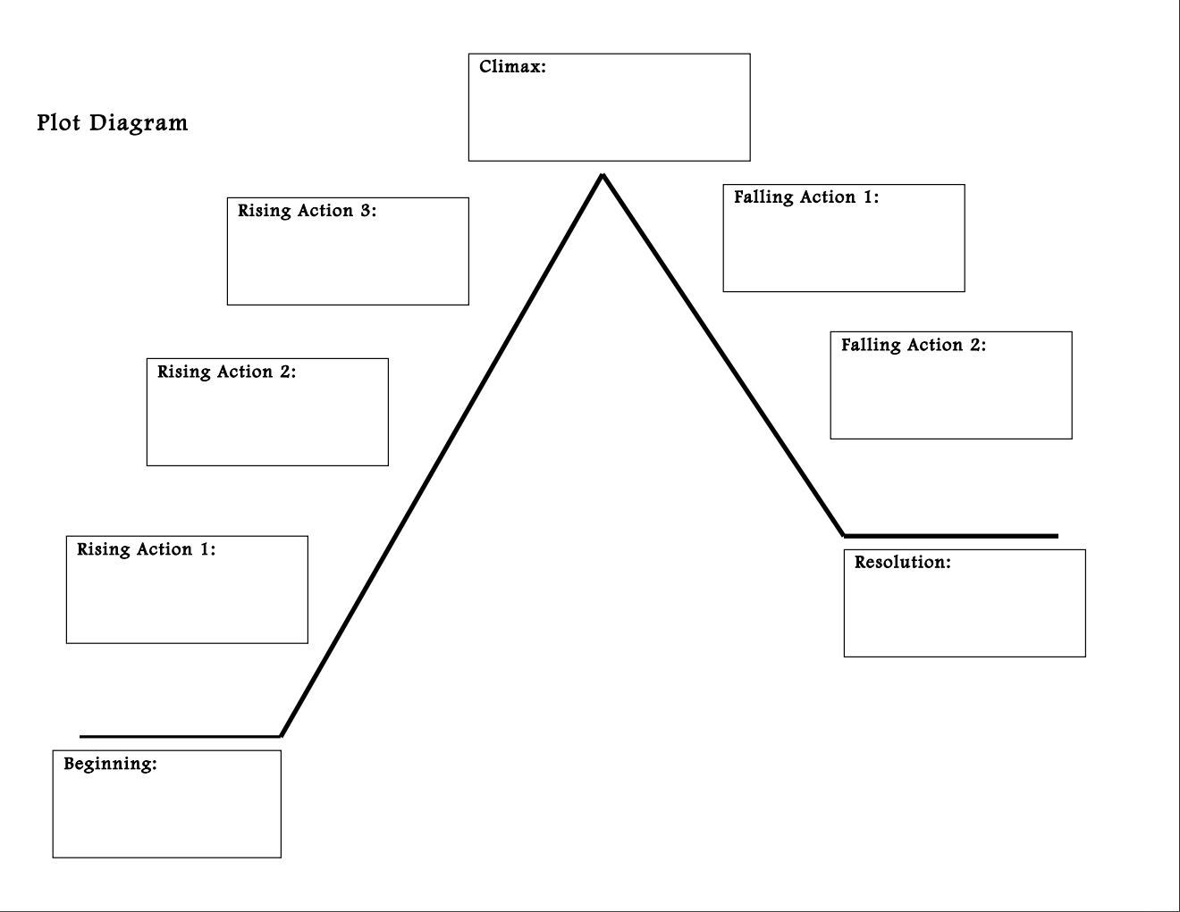

N/A

The Mystery (&The stepfather & The twin sister)

The Powers of Deduction

The Second Journal

The Fright in the Night

The manor house

The inheritance

The First Journal

# Wikipedia Summary of Sir Arthur Conan Doyle’s “The Speckled Band”[6]

In April 1883 Sherlock Holmes and Dr. Watson rise early one morning to meet a young woman named Helen Stoner who fears that her stepfather, Dr. Grimesby Roylott, is threatening her life. Roylott is a doctor who practiced in Calcutta, [India](https://en.wikipedia.org/wiki/India), and was married to Helen's late mother 30 years before when she was a wealthy widow living there. He is also the impoverished last survivor of what was once an extremely wealthy but violent, ill-tempered and amoral Anglo-Saxon aristocratic family of Surrey, and has already served a jail sentence for killing his Indian butler in a rage. After serving his jail sentence Roylott had moved to England and tried to reestablish his practice but gave it up after his wife was killed in a railroad accident eight years before. At his estate of Stoke Moran Roylott with a violent temper and great physical strength becomes the terror of the town in which he engages in brawls including throwing the local blacksmith into a stream.

Helen's twin sister Julia died almost two years earlier, shortly before she was to be married. Helen had heard her sister's dying words, "The speckled band!" but could not decode their meaning. Helen herself is now engaged. She has begun to hear strange noises and observe strange activities around Stoke Moran, the impoverished and heavily mortgaged estate where she and her stepfather live.

Dr. Roylott also keeps strange company at the estate. He is friendly with a band of Gypsies on the property, and he has a cheetah and a baboon as pets. For some time, he has been making changes to the house. Before Helen's sister's death, he had modifications made inside the house and is now having the outside wall repaired, forcing Helen to move into the room where her sister died.

Holmes listens carefully to Helen's story and agrees to take the case. He plans a visit to the manor later in the day. Before he can leave, he is visited by Dr. Roylott himself, who threatens him should he interfere. Undaunted, Holmes proceeds to the courthouse, where he examines Helen's late mother's will, and then to the countryside.

At Stoke Moran, Holmes scrutinizes the premises inside and out. Among the strange features that he discovers are a bed anchored to the floor, a bell cord that is not attached to any bell, and a ventilator hole between Helen's temporary room and that of Dr. Roylott.

Holmes and Watson arrange to spend the night in Helen's room. In darkness, they wait until about three in the morning; suddenly, a slight metallic noise and a dim light through the ventilator prompt Holmes to action. Quickly lighting a candle, he discovers on the bell cord the "speckled band"—a venomous snake. He strikes at the snake with his riding crop, driving it back through the ventilator. Agitated, it fatally attacks Roylott, who had been waiting for it to return after killing Helen. Holmes identifies the snake as an Indian swamp adder and reveals to Watson the motive: the late wife's will which had provided an annual income of $1,100 but had dropped to annual income of $750 sterling [when she passed way], of which each daughter could claim one third ($250) upon marriage. Thus, Dr. Roylott plotted to remove both of his stepdaughters before they married to avoid losing most of the fortune he controlled. Holmes admits his attack on the snake may make him indirectly responsible for Roylott's demise, but he does not foresee it troubling him.

# The Pieces of the Puzzle

*The First Journal*

Eight years after the case, Dr. Watson decided to write down the story of how Dr. Grimesby Roylott died.

*The Mystery*

In April of 1883, Helen Stoner leaves her home in the country to ask Sherlock Holmes and Dr. Watson for help.

Helen has recently become engaged.

“A month ago, however, a dear friend, whom I have known for many years, has done me the honour to ask my hand in marriage. His name is Armitage—Percy Armitage—the second son of Mr. Armitage, of Crane Water, near Reading. My stepfather has offered no opposition to the match, and we are to be married in the course of the spring. Two days ago some repairs were started in the west wing of the building*, and my bedroom wall has been pierced, so that I have had to move into the chamber in which my sister died, and to sleep in the very bed in which she slept. Imagine, then, my thrill of terror when last night, as I lay awake, thinking over her terrible fate, I suddenly heard in the silence of the night the low whistle which had been the herald of her own death. I sprang up and lit the lamp, but nothing was to be seen in the room. I was too shaken to go to bed again, however, so I dressed, and as soon as it was daylight I slipped down, got a dog-cart at the Crown Inn, which is opposite, and drove to Leatherhead, from whence I have come on this morning with the one object of seeing you and asking your advice.”

Holmes and Watson agree to the case.

*The Stepfather*

In India, in 1853, Dr. Grimesby Roylott -- a broke aristocrat -- married Ms. Stoner -- a rich widow with twin daughters (Helen and Julia Stoner). Dr. Roylott kills a servant in a rage and goes to jail. When he gets out of jail, the family moves back to England. He tries to reestablish his doctor practice, but he cannot. In 1875, Ms. Stoner is killed in a train accident, leaving her daughters in the care of their stepfather. Dr. Grimesby Roylott has become more violent, ill tempered, and strange. He gets into a fight with the local blacksmith and throwing the man into a stream. He also collects exotic animals, lets strangers live on his property, and has been making many modifications to their house.

*The Inheritance*

Before visiting the country house, Holmes does investigates the Helen Stoner and her stepfather. He finds the will of Helen’s mother. Immediately after her death, Dr. Grimesby Roylott received $1100 a year, but there was a setback and he now receives $750 a year. Each daughter -- Helen and Julia Stoner -- get $250 a year after marrying. As Holmes says, “My morning’s work has not been wasted, since it has proved that he [Dr. Grimesby Roylott] has the very strongest motives for standing in the way of anything of the sort.” While Holmes is investigating, Dr. Watson gets a visit from Dr. Roylott who tells him not to

*The Twin Sister*

In 1881, Julia meets a man and they get engaged. Tragically, she dies before she marries. The night she dies, Julia asks Helen if she has heard a whistling in the middle of the night. Helen says no. Then both go to bed. Helen describes the rest of the event,

Suddenly, amid all the hubbub of the gale, there burst forth the wild scream of a terrified woman. I knew that it was my sister’s voice. I sprang from my bed, wrapped a shawl round me, and rushed into the corridor. As I opened my door I seemed to hear a low whistle, such as my sister described, and a few moments later a clanging sound, as if a mass of metal had fallen. As I ran down the passage, my sister’s door was unlocked, and revolved slowly upon its hinges. I stared at it horror-stricken, not knowing what was about to issue from it. By the light of the corridor-lamp I saw my sister appear at the opening, her face blanched with terror, her hands groping for help, her whole figure swaying to and fro like that of a drunkard. I ran to her and threw my arms round her, but at that moment her knees seemed to give way and she fell to the ground. She writhed as one who is in terrible pain, and her limbs were dreadfully convulsed…As I bent over her she suddenly shrieked out in a voice which I shall never forget, ‘Oh, my God! Helen! It was the band! The speckled band!’ There was something else which she would fain have said, and she stabbed with her finger into the air in the direction of the doctor’s room, but a fresh convulsion seized her and choked her words. I rushed out, calling loudly for my stepfather, and I met him hastening from his room in his dressing-gown. When he reached my sister’s side she was unconscious, and though he poured brandy down her throat and sent for medical aid from the village, all efforts were in vain, for she slowly sank and died without having recovered her consciousness. Such was the dreadful end of my beloved sister.

*The Second Journal*

After Finding Dr. Roylott’s body, Watson updates us from 8 years later. He writes,

“Such are the true facts of the death of Dr. Grimesby Roylott, of Stoke Moran. It is not necessary that I should prolong a narrative which has already run to too great a length by telling how we broke the sad news to the terrified girl, how we conveyed her by the morning train to the care of her good aunt at Harrow, of how the slow process of official inquiry came to the conclusion that the doctor met his fate while indiscreetly playing with a dangerous pet.”

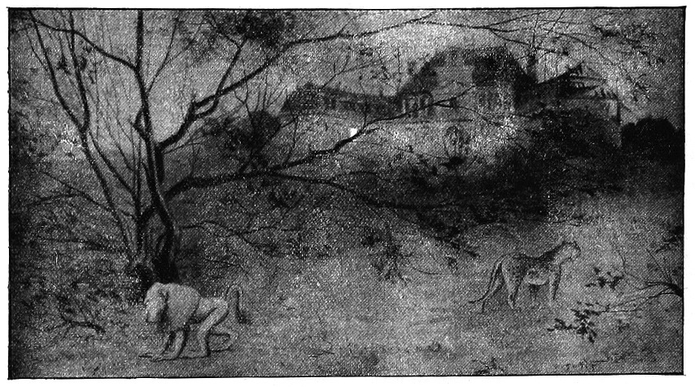*The Manor House*

Thesame day Helen visits them, Holmes and Watson go to the country home to stay the night. When they arrive, they investigate the rooms. Helen previously described the layout of the house to them.

She says,

The manor-house is…very old, and only one wing is now inhabited. The bedrooms in this wing are on the ground floor, the sitting-rooms being in the central block of the buildings. Of these bedrooms the first is Dr. Roylott’s, the second my sister’s [Julia], and the third my own [Helen]. There is no communication between them, but they all open out into the same corridor…The windows of the three rooms open out upon the lawn.

In Helen Stoner’s [current] room, they find a rope that does not lead anywhere next to the ventilator. They also find that the bed is bolted to the floor next to the ventilator. When they go into Dr. Grimesby Roylott’s room they find a chair underneath his ventilator, a safe, a saucer of milk, and a whip.

*The Fright in the Night*

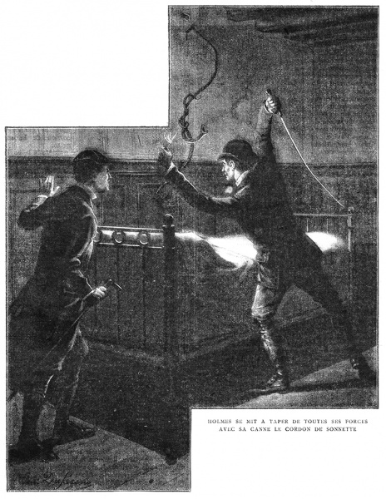At about 3am in Helen Stoner’s room, Holmes and Watson see a light coming through the ventilator, smell burning oil and metal, and hear a whistle. Holmes jumps up with a candle and illuminates the rope. There, he sees a snake -- the speckled band. He hits it with a whip. The snake goes back through the ventilator and attacks Dr. Grimesby Roylott (it is agitated). When Holmes and Watson go into Grimesby’s room and find him dead, sitting in his chair. Watson says,

It was a singular sight which met our eyes. On the table stood a dark-lantern with the shutter half open, throwing a brilliant beam of light upon the iron safe, the door of which was ajar. Beside this table, on the wooden chair, sat Dr. Grimesby Roylott clad in a long grey dressing-gown, his bare ankles protruding beneath, and his feet thrust into red heelless Turkish slippers. Across his lap lay the short stock with the long lash which we had noticed during the day. His chin was cocked upward and his eyes were fixed in a dreadful, rigid stare at the corner of the ceiling. Round his brow he had a peculiar yellow band, with brownish speckles, which seemed to be bound tightly round his head. As we entered he made neither sound nor motion…I took a step forward. In an instant his strange headgear began to move, and there reared itself from among his hair the squat diamond-shaped head and puffed neck of a loathsome serpent.

*The Powers of Deduction*

On the way home from The Manor House, Holmes reveals how the killings happened. He says,

My attention was speedily drawn, as I have already remarked to you, to this ventilator, and to the bell-rope which hung down to the bed. The discovery that this was a dummy, and that the bed was clamped to the floor, instantly gave rise to the suspicion that the rope was there as a bridge for something passing through the hole and coming to the bed. The idea of a snake instantly occurred to me, and when I coupled it with my knowledge that the doctor was furnished with a supply of creatures from India, I felt that I was probably on the right track.

Then I thought of the whistle. Of course he must recall the snake before the morning light revealed it to the victim. He had trained it, probably by the use of the milk which we saw, to return to him when summoned. He would put it through this ventilator at the hour that he thought best, with the certainty that it would crawl down the rope and land on the bed. It might or might not bite the occupant, perhaps she might escape every night for a week, but sooner or later she must fall a victim.

I had come to these conclusions before ever I had entered his room. An inspection of his chair showed me that he had been in the habit of standing on it, which of course would be necessary in order that he should reach the ventilator. The sight of the safe, the saucer of milk, and the loop of whipcord were enough to finally dispel any doubts which may have remained. The metallic clang heard by Miss Stoner was obviously caused by her stepfather hastily closing the door of his safe upon its terrible occupant.”

1. E.M. Forester, ‘“The King died and then the Queen died’ is story. ‘The King died and then the Queen died of grief’ is plot.”
2. E.M. Forester, ‘“The King died and then the Queen died’ is story. ‘The King died and then the Queen died of grief’ is plot.”
3. Plot Map created by Sarah Scholl. Accessed through a free download on Teachers pay teachers website. Here is a link to the PDF: PlotDiagramTemplate-1.pdf.
4. Source: <https://etc.usf.edu/lit2go/32/the-adventures-of-sherlock-holmes/352/adventure-8-the-adventure-of-the-speckled-band/>
5. Source: <https://www.arthur-conan-doyle.com/index.php/The_Adventure_of_the_Speckled_Band>
6. Source <https://en.wikipedia.org/wiki/The_Adventure_of_the_Speckled_Band>